Dynamic Memory Attacks

1. Do not access freed memory

Noncompliant Code Example 1: Incorrect List Freeing

#include <stdio.h>
#include <stdlib.h>

// Define a structure for a linked list node
struct node {
int value;
struct node *next;
};

// Function to create a new node
struct node* create_node(int value) {
struct node *new_node = (struct node *)malloc(sizeof(struct node));
if (!new_node) {
printf("Memory allocation failed\n");
exit(1);
}
new_node->value = value;
new_node->next = NULL;
return new_node;
}

// Function to append a node to the linked list
void append_node(struct node **head, int value) {
struct node *new_node = create_node(value);
if (*head == NULL) {
*head = new_node;
return;
}
struct node *temp = *head;
while (temp->next != NULL) {
temp = temp->next;
}
temp->next = new_node;
}

// Noncompliant function to free a linked list (incorrect method)
void free_list(struct node *head) {
for (struct node *p = head; p != NULL; p = p->next) {
free(p); // Incorrectly frees p before accessing p->next
}
}

// Function to print the list (for debugging purposes)
void print_list(struct node *head) {
struct node *temp = head;
while (temp != NULL) {
printf("%d -> ", temp->value);
temp = temp->next;
}
printf("NULL\n");
}

int main() {
// Create a linked list
struct node *head = NULL;
append_node(&head, 1);
append_node(&head, 2);
append_node(&head, 3);
append_node(&head, 4);

printf("Linked list before freeing:\n");
print_list(head);

// Free the list (incorrectly)
free_list(head);

return 0;
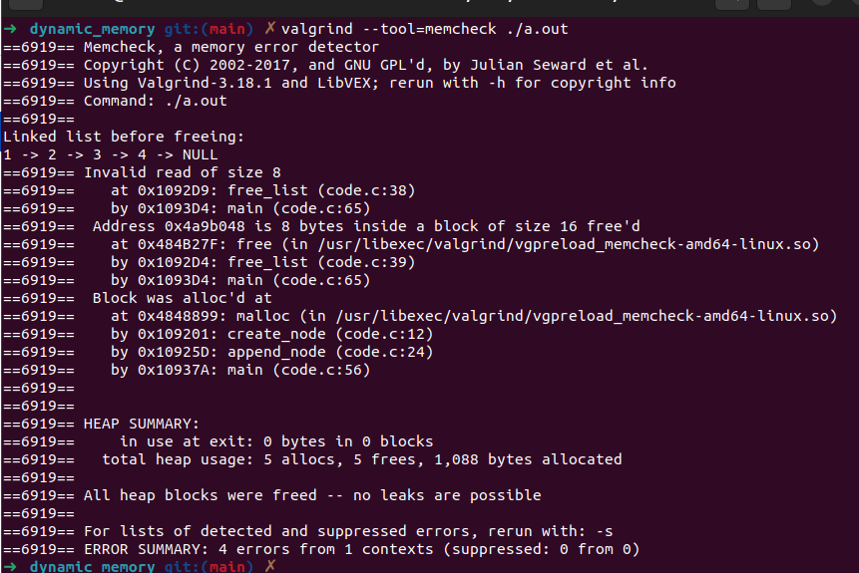
}

Compliant Code: Correct List Freeing

#include <stdio.h>
#include <stdlib.h>

// Define a structure for a linked list node
struct node {
int value;
struct node *next;
};

// Function to create a new node
struct node* create_node(int value) {
struct node *new_node = (struct node *)malloc(sizeof(struct node));
if (!new_node) {
printf("Memory allocation failed\n");
exit(1);
}
new_node->value = value;
new_node->next = NULL;
return new_node;
}

// Function to append a node to the linked list
void append_node(struct node **head, int value) {
struct node *new_node = create_node(value);
if (*head == NULL) {
*head = new_node;
return;
}
struct node *temp = *head;
while (temp->next != NULL) {
temp = temp->next;
}
temp->next = new_node;
}

// Compliant function to free a linked list (correct method)
void free_list(struct node *head) {
struct node *q; // Temporary pointer to store the next node
for (struct node *p = head; p != NULL; p = q) {
q = p->next; // Store p->next before freeing p
free(p); // Free the current node
}
}

// Function to print the list (for debugging purposes)
void print_list(struct node *head) {
struct node *temp = head;
while (temp != NULL) {
printf("%d -> ", temp->value);
temp = temp->next;
}
printf("NULL\n");
}

int main() {
// Create a linked list
struct node *head = NULL;
append_node(&head, 1);
append_node(&head, 2);
append_node(&head, 3);
append_node(&head, 4);

printf("Linked list before freeing:\n");
print_list(head);

// Free the list (correctly)
free_list(head);

return 0;
}

Noncompliant Code Example 2: Use-After-Free Vulnerability

#include <stdlib.h>
#include <string.h>
#include <stdio.h>

int main(int argc, char *argv[]) {
char *return_val = 0;
const size_t bufsize = strlen(argv[0]) + 1; // Calculate buffer size
char *buf = (char *)malloc(bufsize); // Allocate memory
if (!buf) {
return EXIT_FAILURE;
}

// Free the buffer
free(buf);

// Incorrectly writing to the buffer after it has been freed (use-after-free)
strcpy(buf, argv[0]); // Undefined behavior

return EXIT_SUCCESS;
}
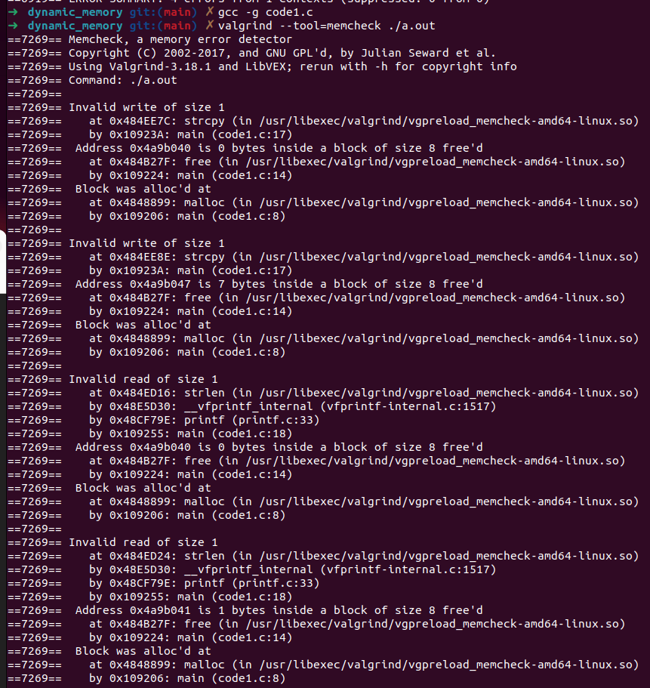
x

Compliant Code Solution 2: Prevent Use-After-Free

#include <stdlib.h>
#include <string.h>
#include <stdio.h>

int main(int argc, char *argv[]) {
char *return_val = 0;
const size_t bufsize = strlen(argv[0]) + 1; // Calculate buffer size
char *buf = (char *)malloc(bufsize); // Allocate memory
if (!buf) {
return EXIT_FAILURE;
}

// Correctly use the buffer and free it only after its final use
strcpy(buf, argv[0]); // Copy string into buffer
free(buf); // Free the buffer after its last use

return EXIT_SUCCESS;
}

Noncompliant Code Example 3: Double-Free Vulnerability with realloc()

#include <stdlib.h>

void f(char *c_str1, size_t size) {
char *c_str2 = (char *)realloc(c_str1, size); // Try reallocating memory
if (c_str2 == NULL) {
free(c_str1); // Double-free occurs if realloc() returns NULL
}
}

int main() {
char *myString = (char *)malloc(10 * sizeof(char));
if (!myString) {
return EXIT_FAILURE;
}

// Attempt to reallocate memory
f(myString, 0); // Calling with zero size could lead to double-free

return 0;
}

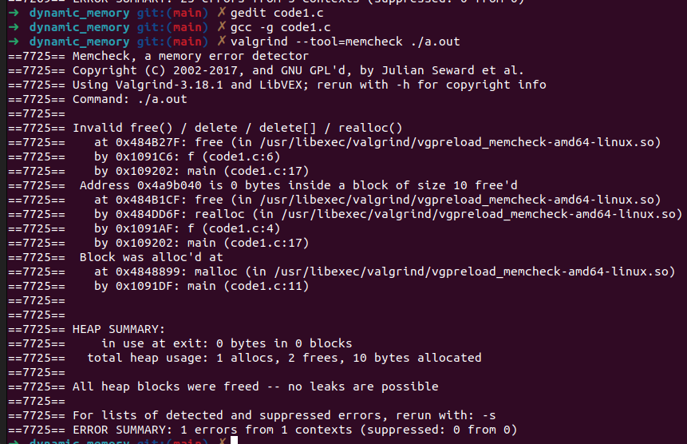
s

Compliant Code Solution 3: Prevent Double-Free with realloc()

#include <stdlib.h>

void f(char *c_str1, size_t size) {
if (size != 0) {
char *c_str2 = (char *)realloc(c_str1, size); // Try reallocating memory
if (c_str2 == NULL) {
free(c_str1); // Free only if realloc() fails and size is non-zero
}
} else {
free(c_str1); // Free explicitly if size is zero
}
}

int main() {
char *myString = (char *)malloc(10 * sizeof(char));
if (!myString) {
return EXIT_FAILURE;
}

// Safely reallocate memory
f(myString, 10); // Attempting to resize correctly

return 0;
}

2. Free dynamically allocated memory when no longer needed

Noncompliant Code Example: Memory Not Freed

#include <stdlib.h>
#include <stdio.h>

enum { BUFFER_SIZE = 32 };

// Function that allocates memory but does not free it
int f(void) {
char *text_buffer = (char *)malloc(BUFFER_SIZE);
if (text_buffer == NULL) {
return -1; // Allocation failed
}

// Do something with text_buffer (omitted for brevity)

// Memory not freed before the function returns
return 0; // Memory leak occurs here
}

int main() {
// Call the function that leaks memory
f();
return 0;}
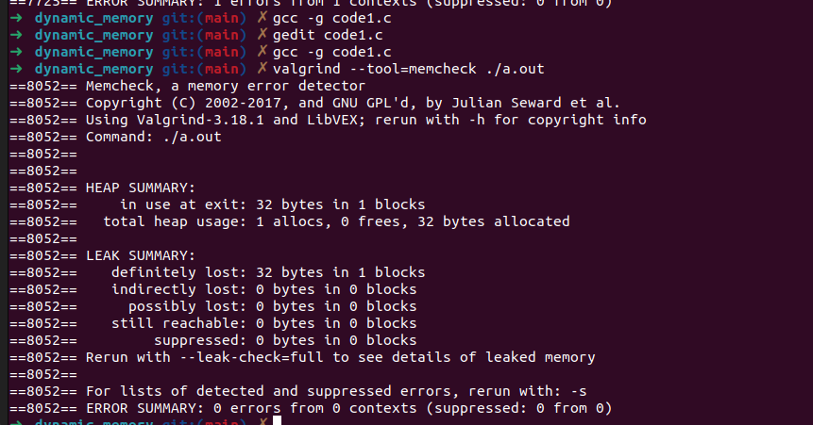

Compliant Solution: Memory Freed

#include <stdlib.h>
#include <stdio.h>

enum { BUFFER_SIZE = 32 };

// Function that allocates memory and frees it afterwards
int f(void) {
char *text_buffer = (char *)malloc(BUFFER_SIZE);
if (text_buffer == NULL) {
return -1; // Allocation failed
}

// Do something with text_buffer (omitted for brevity)

// Free allocated memory before returning
free(text_buffer);
return 0;
}

int main() {
// Call the compliant function
f();
return 0;
}

Exception Example: Static Pointer Does Not Need to be Freed

#include <stdlib.h>
#include <stdio.h>

enum { BUFFER_SIZE = 32 };

// Function using a static pointer, memory doesn't need to be freed
int f(void) {
static char *text_buffer = NULL; // Static pointer with lifetime until program termination
if (text_buffer == NULL) {
text_buffer = (char *)malloc(BUFFER_SIZE);
if (text_buffer == NULL) {
return -1; // Allocation failed
}
}

// Do something with text_buffer (omitted for brevity)

// Memory does not need to be freed
return 0;
}

int main() {
// Call the function using static memory
f();
return 0;
}

3. Allocate and copy structures containing a flexible array member dynamically

1. Noncompliant Code Example (Storage Duration)

#include <stddef.h>
#include <stdio.h>

// Structure with a flexible array member
struct flex_array_struct {
size_t num;
int data[];
};

void func(void) {
struct flex_array_struct flex_struct; // Automatic storage duration
size_t array_size = 4;

/* Initialize structure */
flex_struct.num = array_size;

for (size_t i = 0; i < array_size; ++i) {
flex_struct.data[i] = 0; // Undefined behavior
}
}

int main() {
func();
return 0;
}

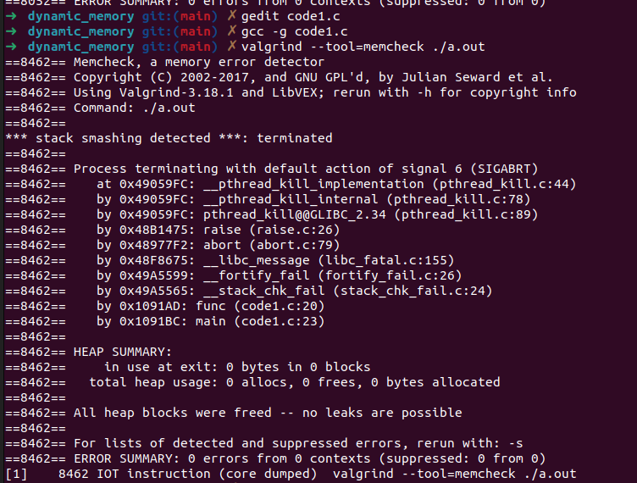
s

Compliant Solution (Storage Duration)

#include <stdlib.h>
#include <stdio.h>

// Structure with a flexible array member
struct flex_array_struct {
size_t num;
int data[];
};

void func(void) {
struct flex_array_struct *flex_struct; // Pointer for dynamic allocation
size_t array_size = 4;

/* Dynamically allocate memory for the struct */
flex_struct = (struct flex_array_struct *)malloc(
sizeof(struct flex_array_struct) + sizeof(int) * array_size);
if (flex_struct == NULL) {
/* Handle error */
fprintf(stderr, "Memory allocation failed\n");
return;
}

/* Initialize structure */
flex_struct->num = array_size;

for (size_t i = 0; i < array_size; ++i) {
flex_struct->data[i] = 0; // Safe access
}

/* Free allocated memory */
free(flex_struct);
}

int main() {
func();
return 0;
}

Noncompliant Code Example (Copying)

#include <stddef.h>
#include <stdio.h>

// Structure with a flexible array member
struct flex_array_struct {
size_t num;
int data[];
};

void func(struct flex_array_struct *struct_a,
struct flex_array_struct *struct_b) {
*struct_b = *struct_a; // Noncompliant: shallow copy
}

int main() {
return 0;
}

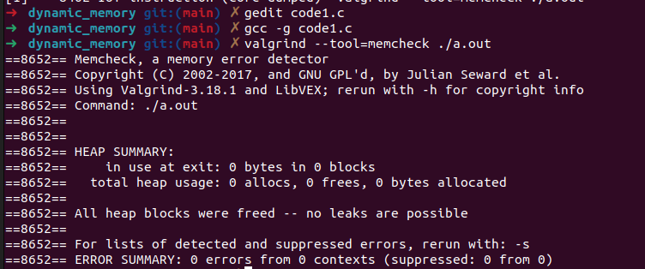
Compliant Solution (Copying)

#include <stdlib.h>
#include <string.h>
#include <stdio.h>

// Structure with a flexible array member
struct flex_array_struct {
size_t num;
int data[];
};

void func(struct flex_array_struct *struct_a,
struct flex_array_struct *struct_b) {
if (struct_a->num > struct_b->num) {
/* Insufficient space; handle error */
fprintf(stderr, "Insufficient space to copy structure\n");
return;
}
memcpy(struct_b, struct_a,
sizeof(struct flex_array_struct) + (sizeof(int) * struct_a->num));
}

int main() {
return 0;
}

4. Only free memory allocated Dynamically

1. Noncompliant Code Example (free)

#include <stdlib.h>
#include <string.h>
#include <stdio.h>

enum { MAX_ALLOCATION = 1000 };

int main(int argc, const char *argv[]) {
char *c_str = NULL;
size_t len;

if (argc == 2) {
len = strlen(argv[1]) + 1;
if (len > MAX_ALLOCATION) {
/* Handle error */
return EXIT_FAILURE;
}
c_str = (char *)malloc(len);
if (c_str == NULL) {
/* Handle error */
return EXIT_FAILURE;
}
strcpy(c_str, argv[1]);
} else {
c_str = "usage: $>a.exe [string]"; // Static string literal
printf("%s\n", c_str);
}
free(c_str); // Error: freeing a pointer not returned by malloc
return 0;
}

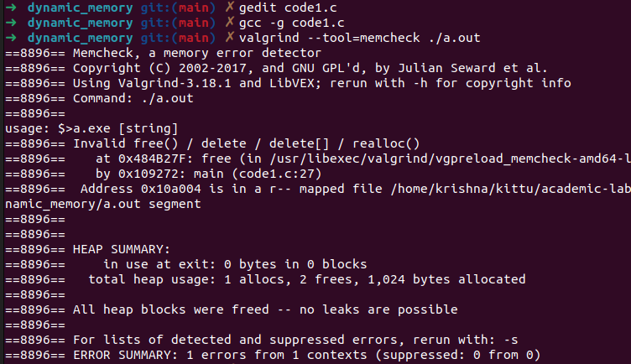
d

Compliant Solution (free)

#include <stdlib.h>
#include <string.h>
#include <stdio.h>

enum { MAX_ALLOCATION = 1000 };

int main(int argc, const char *argv[]) {
char *c_str = NULL;
size_t len;

if (argc == 2) {
len = strlen(argv[1]) + 1;
if (len > MAX_ALLOCATION) {
/* Handle error */
return EXIT_FAILURE;
}
c_str = (char *)malloc(len);
if (c_str == NULL) {
/* Handle error */
return EXIT_FAILURE;
}
strcpy(c_str, argv[1]);
} else {
printf("%s\n", "usage: $>a.exe [string]");
return EXIT_FAILURE;
}
free(c_str); // Safe: freeing dynamically allocated memory
return 0;
}

2. Noncompliant Code Example (realloc)

#include <stdlib.h>

enum { BUFSIZE = 256 };

void f(void) {
char buf[BUFSIZE]; // Automatic storage
char *p = (char *)realloc(buf, 2 * BUFSIZE); // Error: realloc on non-dynamic memory
if (p == NULL) {
/* Handle error */
}
}

int main() {
f();
return 0;
}

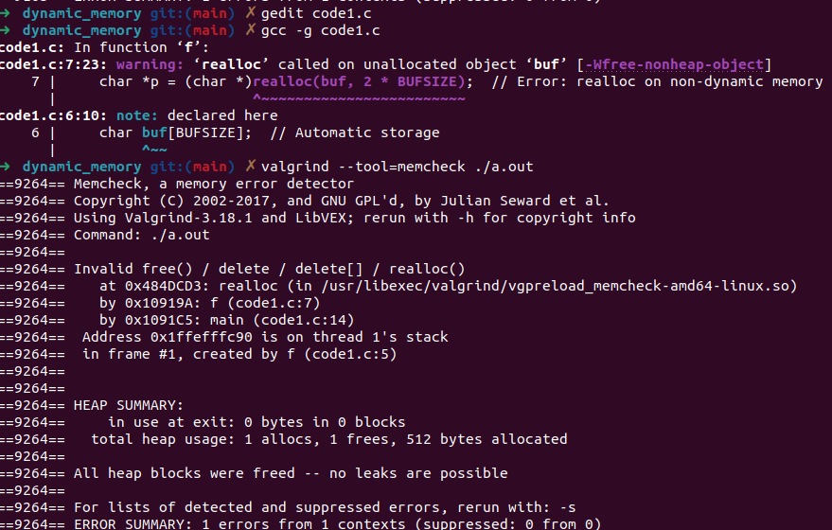
-

Compliant Solution (realloc)

#include <stdlib.h>

enum { BUFSIZE = 256 };

void f(void) {
char *buf = (char *)malloc(BUFSIZE * sizeof(char)); // Dynamic allocation
if (buf == NULL) {
/* Handle error */
return;
}
char *p = (char *)realloc(buf, 2 * BUFSIZE); // Safe: realloc on dynamically allocated memory
if (p == NULL) {
/* Handle error */
free(buf); // Free original buffer on realloc failure
} else {
buf = p; // Use the newly allocated memory
}
free(buf); // Free the allocated memory
}

int main() {
f();
return 0;
}

5. Do not modify the alignment of object by calling realloc()

1. Noncompliant Code Example

#include <stdlib.h>
#include <stdio.h>

void func(void) {
size_t resize = 1024;
size_t alignment = 1 << 12; // 4096 bytes
int *ptr;
int *ptr1;

// Allocate memory with a specific alignment
if (NULL == (ptr = (int *)aligned_alloc(alignment, sizeof(int)))) {
perror("aligned_alloc failed");
exit(EXIT_FAILURE);
}

// Attempt to resize the allocated memory
if (NULL == (ptr1 = (int *)realloc(ptr, resize))) {
perror("realloc failed");
free(ptr); // Free the original pointer in case realloc fails
exit(EXIT_FAILURE);
}

// Use ptr1 as needed...

// Free the resized memory
free(ptr1);
}

int main(void) {
func();
return 0;
}

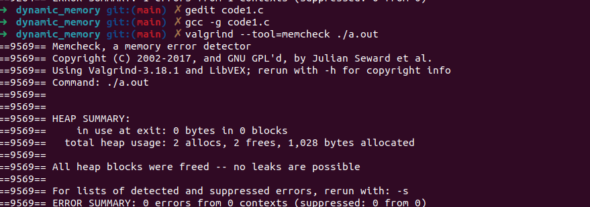
-

Compliant Solution

#include <stdlib.h>
#include <stdio.h>
#include <string.h>

void func(void) {
size_t resize = 1024;
size_t alignment = 1 << 12; // 4096 bytes
int *ptr;
int *ptr1;

// Allocate memory with a specific alignment
if (NULL == (ptr = (int *)aligned_alloc(alignment, sizeof(int)))) {
perror("aligned_alloc failed");
exit(EXIT_FAILURE);
}

// Allocate new aligned memory for resizing
if (NULL == (ptr1 = (int *)aligned_alloc(alignment, resize))) {
perror("aligned_alloc for resize failed");
free(ptr); // Free the original pointer in case of failure
exit(EXIT_FAILURE);
}

// Copy the contents of the original memory to the new memory
memcpy(ptr1, ptr, sizeof(int));

// Free the old memory
free(ptr);

// Use ptr1 as needed...

// Free the resized memory
free(ptr1);
}

int main(void) {
func();
return 0;
}

6. Allocate sufficient memory for an object

1. Noncompliant Code Example (Pointer)

Code:

#include <stdlib.h>
#include <time.h>
#include <stdio.h>

struct tm *make_tm(int year, int mon, int day, int hour,
int min, int sec) {
struct tm *tmb;
tmb = (struct tm *)malloc(sizeof(tmb)); // Incorrect allocation
if (tmb == NULL) {
return NULL;
}
*tmb = (struct tm) {
.tm_sec = sec, .tm_min = min, .tm_hour = hour,
.tm_mday = day, .tm_mon = mon, .tm_year = year
};
return tmb;
}

int main() {
struct tm *date = make_tm(2024, 10, 31, 12, 30, 45);
if (date == NULL) {
printf("Memory allocation failed.\n");
return 1;
}
printf("Time: %d-%d-%d %d:%d:%d\n", date->tm_year, date->tm_mon, date->tm_mday,
date->tm_hour, date->tm_min, date->tm_sec);
free(date); // Free allocated memory
return 0;
}

Output:

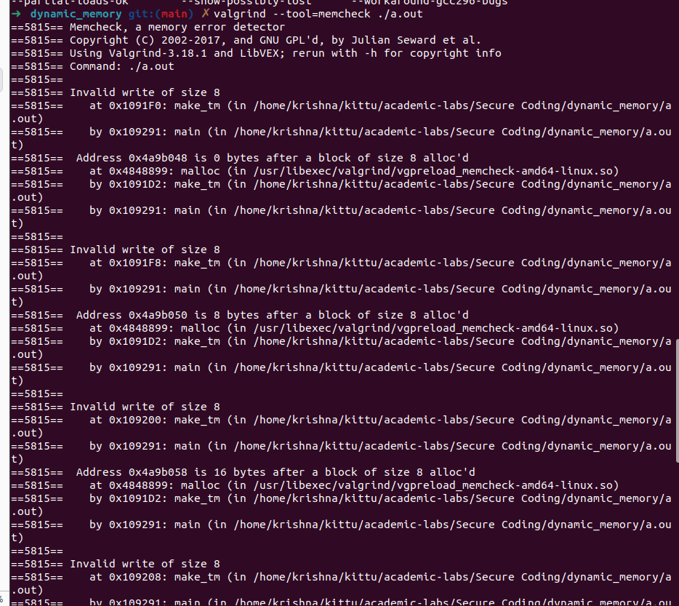
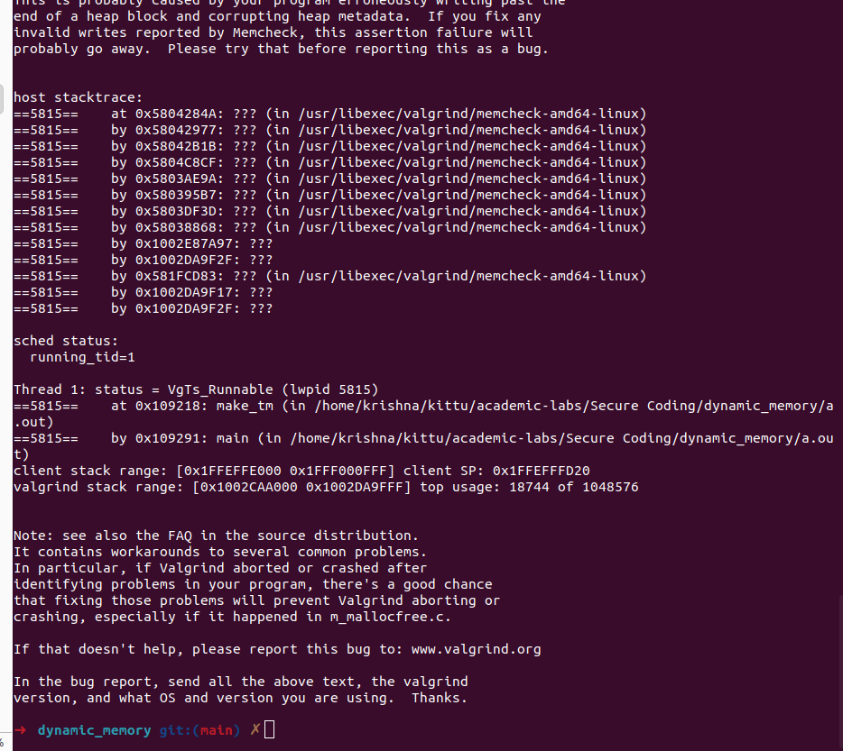

This code incorrectly allocates memory using the size of a pointer (sizeof(tmb)), which leads to an under-allocation for the actual struct tm object.

Compliant Solution (Pointer)

Code:

#include <stdlib.h>
#include <time.h>
#include <stdio.h>

struct tm *make_tm(int year, int mon, int day, int hour,
int min, int sec) {
struct tm *tmb;
tmb = (struct tm *)malloc(sizeof(*tmb)); // Correct allocation
if (tmb == NULL) {
return NULL;
}
*tmb = (struct tm) {
.tm_sec = sec, .tm_min = min, .tm_hour = hour,
.tm_mday = day, .tm_mon = mon, .tm_year = year
};
return tmb;
}

int main() {
struct tm *date = make_tm(2024, 10, 31, 12, 30, 45);
if (date == NULL) {
printf("Memory allocation failed.\n");
return 1;
}
printf("Time: %d-%d-%d %d:%d:%d\n", date->tm_year, date->tm_mon, date->tm_mday,
date->tm_hour, date->tm_min, date->tm_sec);
free(date); // Free allocated memory
return 0;
}

Output:

This version uses sizeof(*tmb) to correctly allocate memory for the struct tm object. This ensures enough memory is reserved for the object.

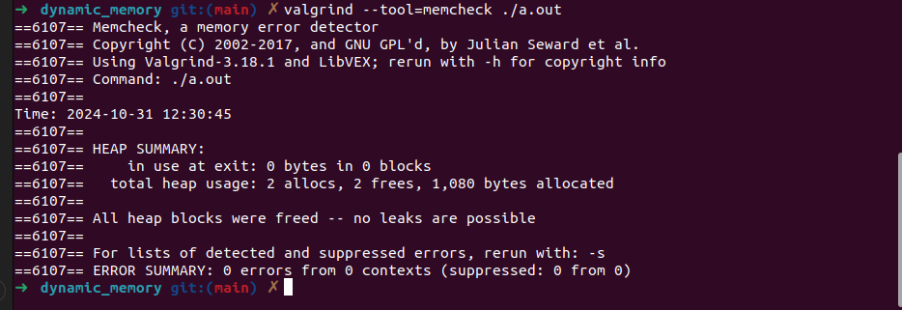

2.Noncompliant Code Example (Integer)

Code:

#include <stdint.h>
#include <stdlib.h>
#include <stdio.h>

void function(size_t len) {
long *p;
if (len == 0 || len > SIZE_MAX / sizeof(long)) {
printf("Overflow detected.\n");
return;
}
p = (long *)malloc(len * sizeof(int)); // Incorrect allocation
if (p == NULL) {
printf("Memory allocation failed.\n");
return;
}
printf("Memory allocated for %zu elements of long (but sized as int).\n", len);
free(p);
}

int main() {
function(10); // Allocate memory for 10 long elements (incorrectly)
return 0;
}

Output:

The array is incorrectly allocated using sizeof(int) instead of sizeof(long), which can lead to buffer overflows on systems where sizeof(long) > sizeof(int
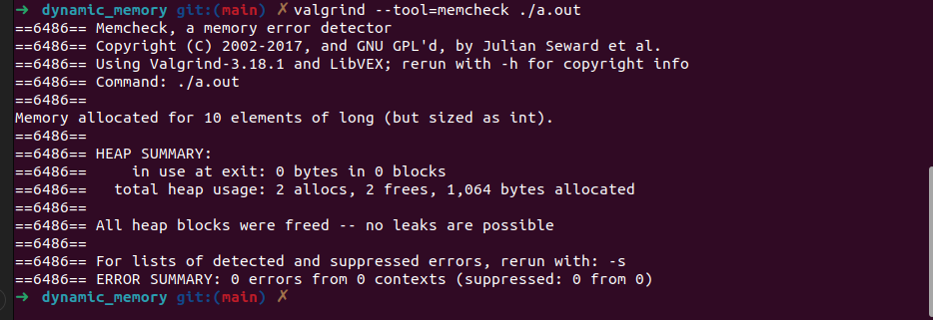

Compliant Solution (Integer)

Code:

#include <stdint.h>
#include <stdlib.h>
#include <stdio.h>

void function(size_t len) {
long *p;
if (len == 0 || len > SIZE_MAX / sizeof(long)) {
printf("Overflow detected.\n");
return;
}
p = (long *)malloc(len * sizeof(long)); // Correct allocation
if (p == NULL) {
printf("Memory allocation failed.\n");
return;
}
printf("Memory allocated for %zu elements of long.\n", len);
free(p);
}

int main() {
function(10); // Correctly allocate memory for 10 long elements
return 0;
}

Output:

This version allocates the correct amount of memory by using sizeof(long) to ensure the buffer is sized properly for long values.

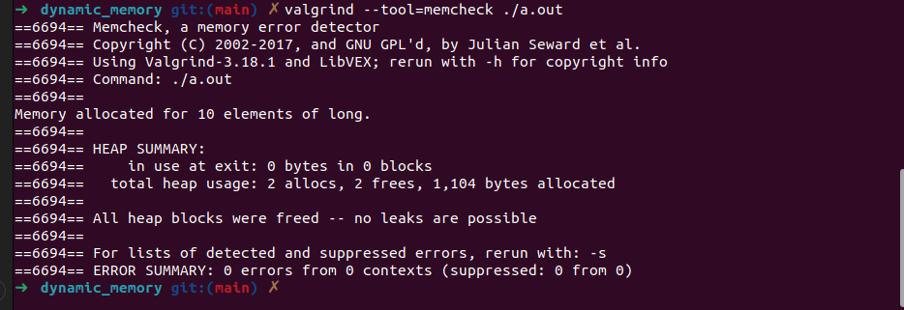

Compliant Solution (Integer using sizeof(*p))

Code:

#include <stdint.h>
#include <stdlib.h>
#include <stdio.h>

void function(size_t len) {
long *p;
if (len == 0 || len > SIZE_MAX / sizeof(*p)) {
printf("Overflow detected.\n");
return;
}
p = (long *)malloc(len * sizeof(*p)); // Correct allocation using sizeof(*p)
if (p == NULL) {
printf("Memory allocation failed.\n");
return;
}
printf("Memory allocated for %zu elements of long (using sizeof(*p)).\n", len);
free(p);
}

int main() {
function(10); // Correctly allocate memory for 10 long elements
return 0;
}

Ouptut:

This version simplifies the allocation by using sizeof(*p) to compute the size of the memory needed. This approach avoids errors when changing the type of p.
